# CS 255 System Design Document Jordan Purdy

## UML Diagrams

### UML Use Case Diagram

### UML Activity Diagrams

### UML Sequence Diagram

### UML Class Diagram

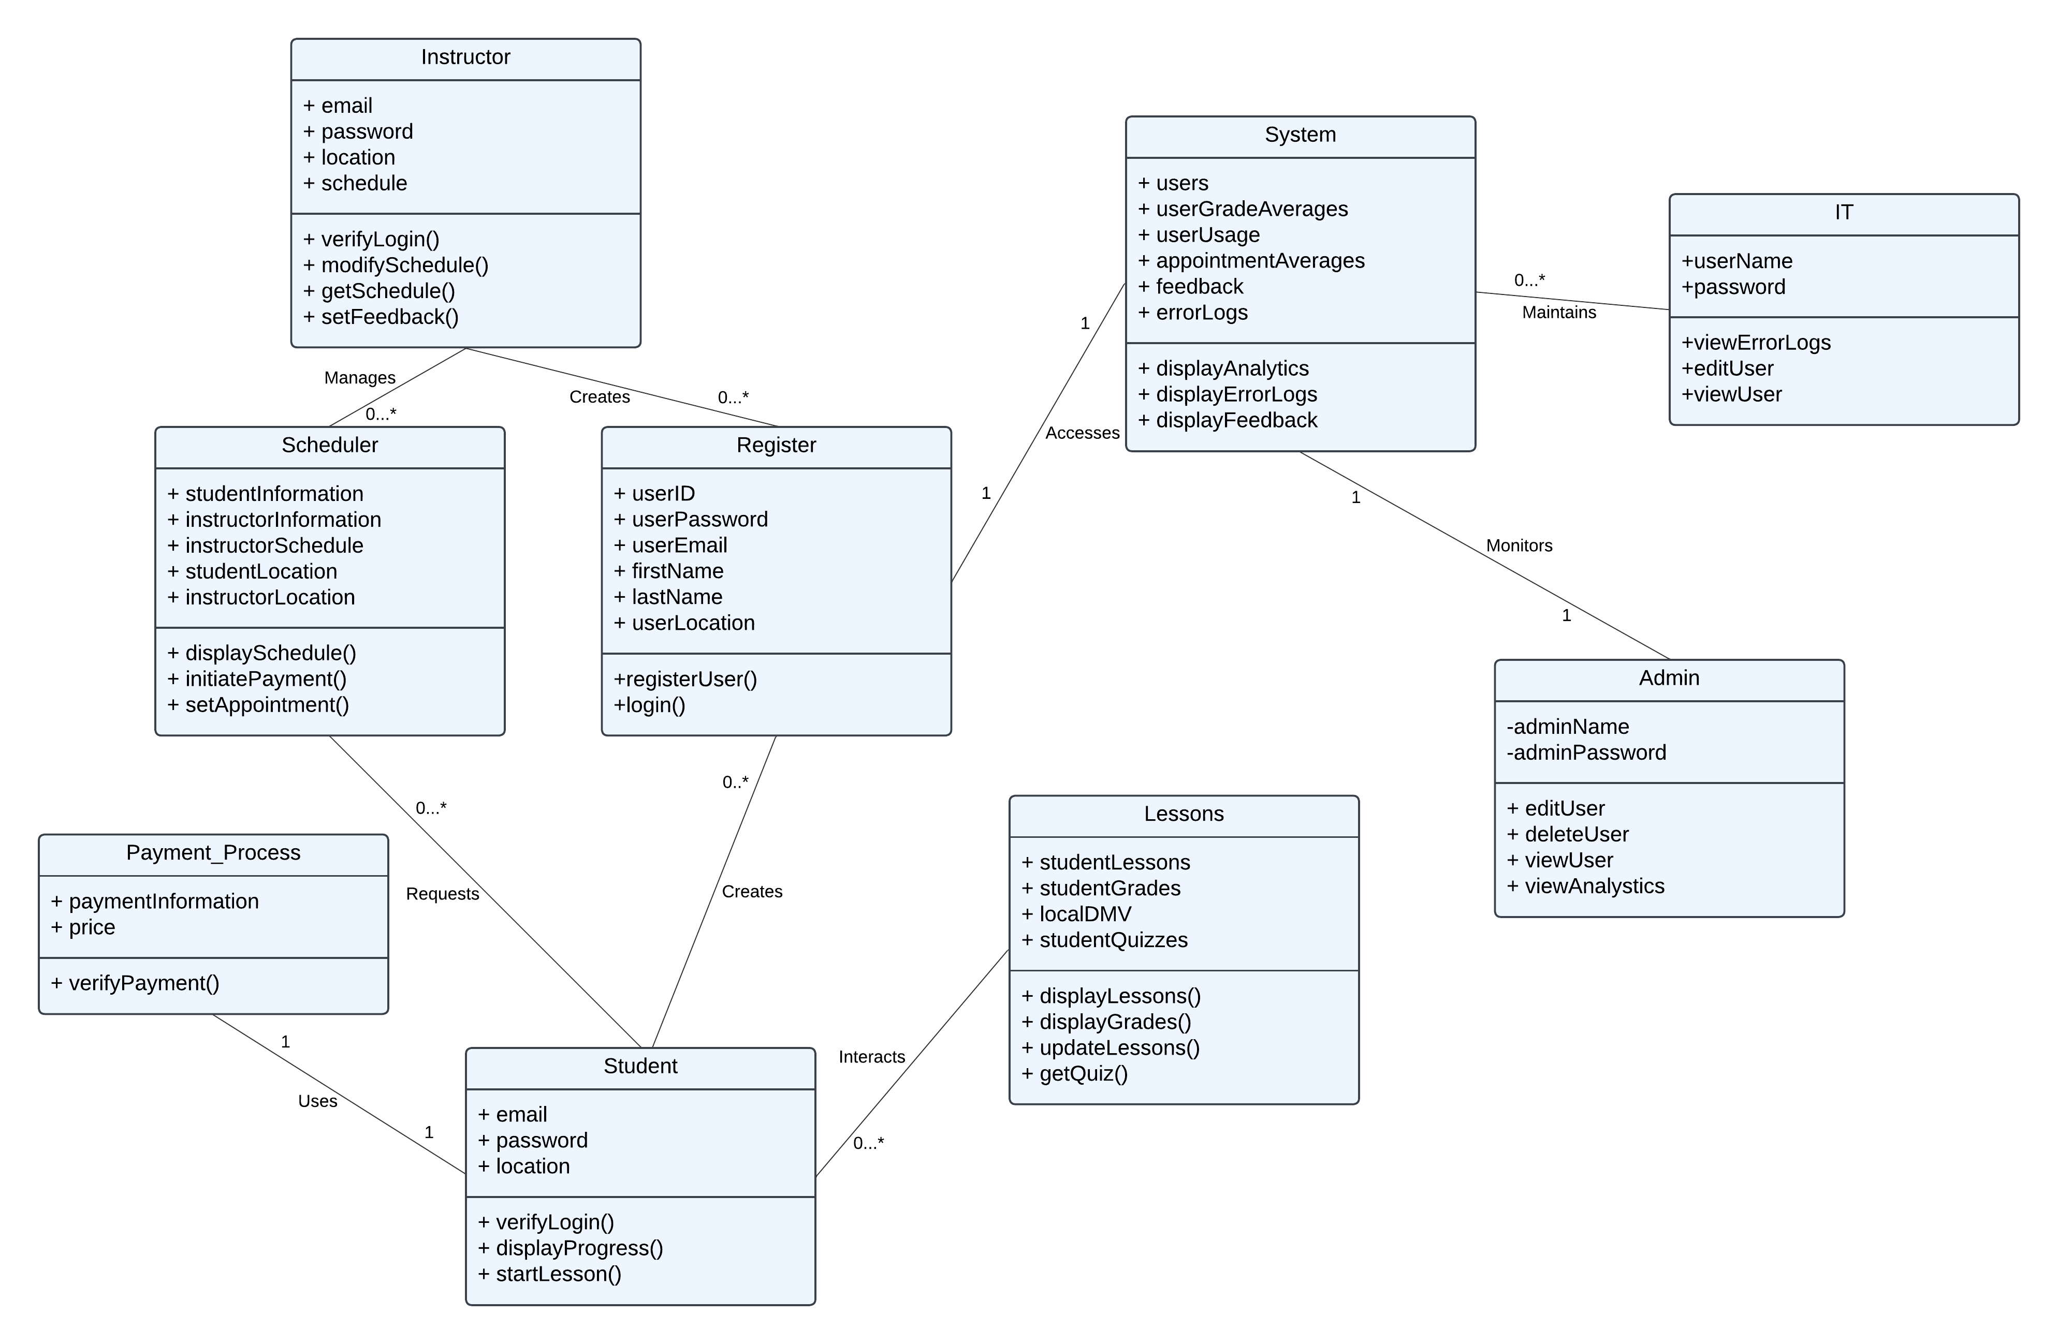

## Technical Requirements

* **Platform and Infrastructure**
  + The system will need some sort of hosting environment like a cloud platform to be scalable and consistently available. It will also need to be designed for modern web applications like Chrome, Firefox, and Safari. Additionally, it should be designed for the most popular mobile operating systems, Android and iOS. Finally, as with all client-server communication systems, it will need to support RESTful APIs.
* **Database and Storage**
  + For structured data like user profiles and schedules, a relational database like MySQL should be used. Unstructured data like the training content and lessons can be done with a NoSQL database like MongoDB. Data backup will be extremely important with this system, therefore daily incremental backups and weekly full backups should be implemented. Finally, the system should start prepared for 10,000 users, with the expectation to scale up to higher loads once adoption takes place.
* **Authentication and Security**
  + Authentication can be done with modern tools like OAuth 2.0 for secure user sessions. Multi-factor or 2-factor authentication like SMS, e-mail, or authenticator applications should be mandatory for all users. All sensitive data like passwords should be encrypted using bcrypt. Consistent monitoring tools like Datadog can be deployed for real-time monitoring if desired.
* **Main tasks**
  + Scheduling should be real-time and be updated dynamically. It should also request user location so that geolocation can be used to provide instructor matching. Payment processing can be done with companies like Stripe or Paypal, and features like refund and transaction tracking/notifications should be implemented. Training materials should support many different formats, such as video, PDFs, quizzes, and offline downloadable documents.
* **Notifications**
  + User notifications can be pushed out using Firebase Cloud Messaging, email, or SMS. Admins and IT should receive real-time notifications for system issues or unusual activity.
* **Analytics**
  + The system should provide weekly reports with information on user engagement, training completion, revenue, and student/instructor feedback. Additionally, critical errors and failures should be stored in a log object for admin and IT review.
* **Legal compliance**
  + System should comply with FERPA (family educational rights and privacy act) for educational data protection, and all websites and applications should follow WCAG guidelines for accessibility and users with disabilities.